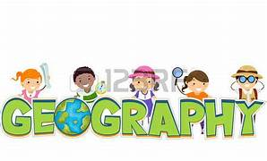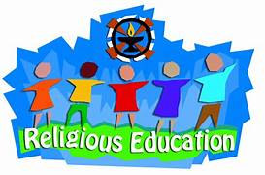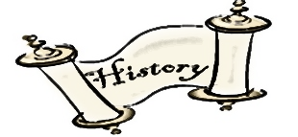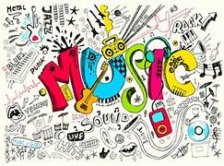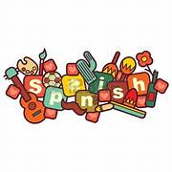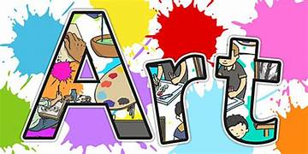

* Greetings and being polite
* Number 1-10
* Colours
* Parts of the body
* Plants
* At the seaside
* Minibeasts
* Sing songs
* Play tuned and untuned instruments musically
* Listen and understand live and recorded music
* Make and combine sounds musically
* Master basic movement, e.g. running jumping, throwing, catching, balance, agility and coordination
* Participate in team games
* Perform dances using simple movement.
* Design purposeful, functional and appealing products
* Generate, model and communicate ideas
* Use a range of tools and materials to complete practical tasks
* Evaluate existing products and own ideas
* Build and improve structure and mechanisms
* Understand where food comes from
* Use a range of materials
* Use drawing, painting and sculpture
* Develop techniques of colour, pattern, texture, line, shape, form and space.
* Learn about a range of artists, craftsmen and designers.

**Locational knowledge**

* Name and locate the world’s continents and oceans
* Compare local area to a non-European country

**Human and physical geography**

* identify seasonal and daily weather patterns in the United Kingdom and the location of hot and cold areas of the world in relation to the Equator and the North and South Poles
* Use basic geographical vocabulary describe a less familiar area
* Use ariel images and maps to create their own maps and diagrams
* Complete simple fieldwork

**Pupils will learn about:**

* changes within living Where appropriate, these should be used to reveal aspects of change in national life
* events beyond living memory that are significant nationally or globally [for example, the Great Fire of London, the first aeroplane flight or events commemorated through festivals or anniversaries]
* the lives of significant individuals in the past who have contributed to national and international achievements. Some should be used to compare aspects of life in different periods [for example, Elizabeth I and Queen Victoria,

Christopher Columbus and Neil Armstrong, William Caxton and Tim Berners-Lee, Pieter Bruegel the Elder and LS Lowry, Rosa Parks and Emily Davison, Mary Seacole and/or Florence Nightingale and Edith Cavell]

* significant historical events, people and places in their own local area

Green Meadow Year 2 Curriculum